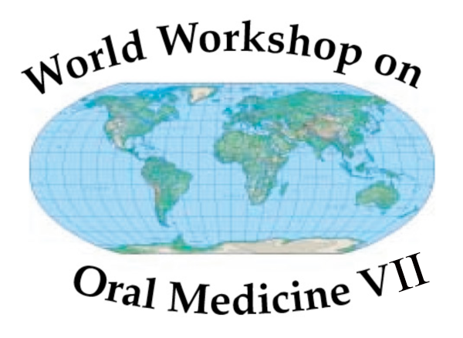

World Workshop on Oral Medicine VII
Assistant Reviewer Application

Deadline for submission: February 1st 2017.

In the mid-1980s, Professor Sir David Mason (UK) and Dr. Dean Millard (US) conceived the idea of convening experts in oral medicine from around the world to explore the current status and future directions of the field. The first 3 World Workshops on Oral Medicine took place at the American Dental Association headquarters in Chicago in 1988, 1993, and 1998; and in 2006, 2010, 2014 the WWOM took place in Puerto Rico and London, and Orlando respectively. At each conference, approximately 50-100 global experts in oral medicine and other fields participated, and worked in sections to rigorously review the current literature and to examine educational standards. The proceedings have been published and widely distributed (see Oral Diseases 2015;21:409–416).

The Steering Committee of the World Workshop VII is committed to encouraging early to mid-career level Oral Medicine clinicians and/or scientists to participate as reviewers in the next Workshop. The meeting is scheduled for September 24th-26th 2018 in Gothenburg, Sweden in conjunction with the meeting of the European Association of Oral Medicine (EAOM) on September 26th-29th 2018. We anticipate an international representation in this group, with representatives from all continents. This international meeting will allow the Oral Medicine trainee or junior faculty member to interact with colleagues from around the world, experience the evidence-based review process, and promote the speciality by identifying the next generation of leaders. The posts are not age limited but will be preferentially awarded to individuals training in Oral Medicine, or to junior faculty early in their careers. Past assistant reviewers will be ineligible but are eligible to apply for a reviewer position.

Each of the 8 groups in the Workshop will have two assistant reviewers assigned to them. They will assist the senior reviewers on the project assigned and in writing the final paper. The chosen individuals will therefore be expected to deliver in a timely manner a significant amount of work and should commit to this. The prepared review will form the discussion focus for the panel of experts at WWOM VII. At all times the reviewer will be guided by the group’s section head. The applicant is asked to rank their first three choices of Workshop Groups in which to participate.

The chosen individuals will receive economy rate travel and 3 nights accommodation expenses to attend the Workshop in Gothenburg, Sweden. The candidate will need to secure further funding to attend the EAOM meeting to be held in Gothenburg the same week. Attendance is encouraged since the Workshop reviews will form a significant component of the meeting.

Application process

The application process comprises three parts (to be completed in English)

- A completed application form, including one 1000 word discussion to a set question, signed by the candidate.
2 The candidate’s current Curriculum vitae to include (i) publications (ii) presentations at meetings (iii) teaching qualifications and experience (iv) management and leadership skills.

3 Supporting structured references from 2 senior colleagues in their current home unit or facility. It is important that candidates should include the names and email addresses for both colleagues. Upon receipt of the application, these colleagues will be sent an email request to assess the candidate by giving scores and comments on an internet-based form.

Please send your application via email to Dr. Ross Kerr ark3@nyu.edu (application form, CV as word document)

The closing date for applications is February 1st, 2017. The awards will be announced before March 15th, 2017 and candidates notified by e-mail of the outcome of their application.

Workshop Groups

Group 1 – Oral Microbiome
Group Head: TBD

Group 2 – Personalized Medicine
Group Head: TBD

Group 3 – Molecular Biology for Oral Medicine Specialists
Group Head: Ilias Alevizos

Group 4 – Use of Biologics in Oral Medicine
Group Head: Scott DeRossi

Group 5 – Consensus on Outcome Measures for Burning Mouth Syndrome
Group Head: Craig Miller

Group 6 – Future of Oral Medicine
Group Head: Mark Drangsholt

Group 7 – Medically Necessary Dental Care
Group Head: Alex White

Group 8 – Pediatric Oral Medicine
Group Head: Catherine Hong

Application form

Title…………………………………………………………………………………

Name………………………………………………………………………………

Date of birth……………………………………………………………………….

Address of unit/institution in which you presently work
……………………………………………………………………………………....

………………………………………………………………………………………

………………………………………………………………………………………

………………………………………………………………………………………

E-mail address……………………………………………………………………..

Telephone number…………………………………………………………………

Present position/title………………….…………………………………………….

Years at post/position………………………………………………………………

Names and e-mail addresses of the 2 senior colleagues

Name………………………………………E-mail………………………………..

Name………………………………………E-mail………………………………..

Preferred Workshop Groups in which you would prefer to participate
(1 = first choice):

1.
2.
3.
How would your involvement with this group impact your career ? (<100 words)

Question

How would you, in your career as an oral medicine specialist, plan to contribute to individual and population health care in your country ? (1000 words maximum)

Use separate or extra sheet if needed

Signature of applicant………………………………………………………………...
Date…………………………………………………………………………………….

